NAT GEO EDUCATOR CERTIFICATION JOURNAL

Table of Contents:
SECTION A: PHASE 1 WORKSHOP page 2
SECTION B: PHASE 2 ACTIVITIES page 5
SECTION C: PHASE 3 CAPSTONE page 9
NAT GEO LEARNING FRAMEWORK page 11

Welcome to the National Geographic Educator Certification Program!
You are participating in this program with a community of like-minded educators who are passionate about teaching students about the world. As you work through each phase of the process, you will have opportunities to interact with ideas about and resources for teaching and learning—beginning with the introductory workshop and culminating in a multimedia capstone project. We’re here to help and support you through each step in the process, and we are excited to make this journey with you!

The Certification Process
See the certification website here. | See program requirements here.

Phase 1: Certification Workshop
Certification begins either with a face-to-face or online workshop. The workshop is a brief introduction to National Geographic’s philosophy on how to teach students about the world and how it works. It sets the stage for the changes in teaching practice that result in students having an understanding and appreciation of the world, empowering them to succeed and make it a better place.

Phase 2: Activate
In Phase 2, you should complete two classroom activities that draw upon your knowledge of the National Geographic Learning Framework (introduced in Phase 1). We challenge you to teach your students about our interconnected world in ways you may not have tried before. You will be asked to reflect on these activities as they relate to the Learning Framework in Phase 3.
Activity 1: Choose and build upon a resource from Nat Geo Ed or your state’s Geographic Alliance website.
Start with a pre-made resource from Nat Geo or your state’s Geographic Alliance, but don’t stop there. Your task is to build upon any of our materials to best suit the unique needs of your classroom. You will be asked to share how you expanded the lesson, how it connected to the Learning Framework, and how students were impacted in Phase 3.
Activity 2: Design an activity that aligns with one of the themes in this list.
Be creative and bring your own teaching philosophy as well as the Learning Framework to your lesson! You will be asked to share a lesson description, how the lesson connected to the Learning Framework, and how students were impacted in Phase 3.
See full instructions for Phase 2 here. | See program requirements here.

Phase 3: Capstone Project
Your capstone project will be a multimedia reflection form. This is your chance to tell us about both of the activities you completed in Phase 2, how they connected to the Learning Framework, and how your students were impacted.
However, you should also choose either Activity 1 or Activity 2 as your “capstone activity.” For your capstone activity, you will be asked to submit the following additional items as part of your multimedia reflection form.
- A lesson plan, in accordance with this template
- 2-6 photographs of student work
- A video that tells the story of your students’ learning in a visual and creative way. See “Capstone Video Requirements” for more details.
See full Phase 3 instructions here. | See program requirements here.

How to Use This Journal
As you go through the three phases of the Nat Geo Certification Program, you will use this journal to record your reflections, document your activities, find information about the process, and plan for your Capstone video. Please read through the instructions in each section. You will use Section B to prepare your activity submission information, but you will not submit this journal at any time. It’s yours to use.

Instructions for joining the Google+ Community
The Nat Geo Educator Certification Google+ Community is a private community for all certification beta testers. Here is a quick link to Google+ Community. Click “Ask to Join” and you will be approved by the next business day.

If you do not have a Google account or haven’t participated in Google+ Communities, please read the instructions in the “Joining the Nat Geo Educator Certification Google+ Community” document.

SECTION A: WORKSHOP

- We Believe In the Power of Science, Exploration, Education, and Storytelling
After watching the “We Believe” video, what’s one word that comes to mind?
Inspiring
- Your Teaching Mission
In one or two sentences, write your personal teaching mission.

My teaching mission is to educate students so they understand, from multiple perspectives, more deeply and broadly about the world (natural and human) they live in.

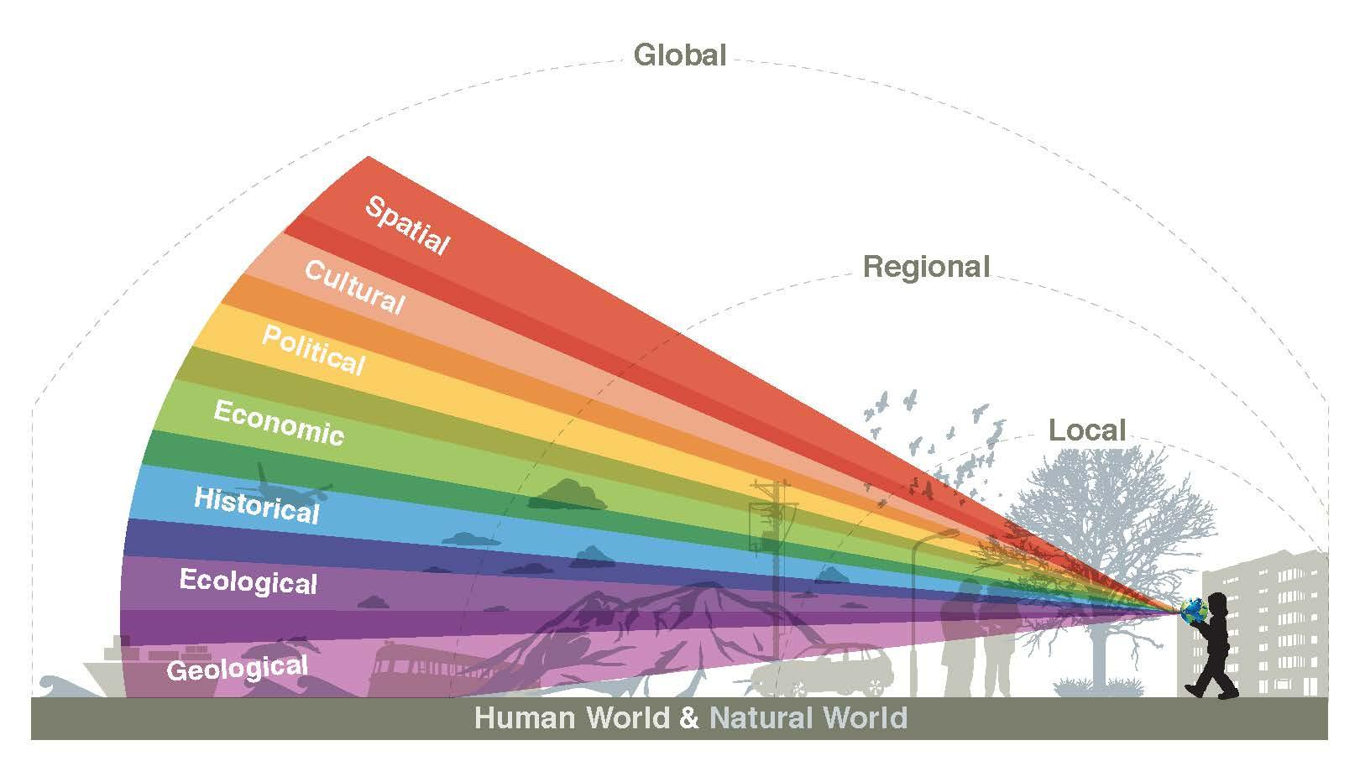

Teaching Students About the World
At National Geographic, we believe that a well-rounded education provides young people with the knowledge of how the human and natural worlds work at local, regional, and global scales. This type of education also teaches young people to use different perspectives to understand the world.

3. How do you teach about the world?
Write down an activity that you do in your classroom or that you’ve heard of that helps students learn about our interconnected world.
I have students create maps (2D and 3D) about different locations (cities and countries) they are most interested in and inspired about. Map making helps them understand different cultures, different geographies, and different histories.

4. Why is it important?
Why is it important to teach students about our interconnected world? What is the impact of this type of teaching on students? Share your ideas in the box below.

It is important that students understand about the interconnected world because if they are to protect the planet for themselves and for future generations, they need to have a good understanding of how their planet works and how to preserve and sustain the planet.

5. Apply the National Geographic Learning Framework
Think about your activity in relation to the Learning Framework, and check off all of the attitudes, skills, and knowledge that apply.
Attitudes |  | Skills |  | Knowledge
Curiosity | * | Observation | * | Our Human Story | *
Responsibility | * | Communication | * | Our Living Planet | *
Empowerment | * | Collaboration | * | Critical Species | *
 |  | Problem Solving | * | New Frontiers | *

Which one or two of the attributes (attitudes and skills) plus one of the knowledge areas was most represented in the activity?

The areas most represented in our activity were: Empowerment and Collaboration and Our Living Plant.

SECTION B: PHASE 2

Activity 1: Choose and build upon a resource from Nat Geo Ed or your state’s Geographic Alliance website.
Start with a pre-made resource from Nat Geo or your state’s Geographic Alliance, but don’t stop there. Your task is to build upon any of our materials to best suit the unique needs of your classroom. You will be asked to share how you expanded the lesson, how it connected to the Learning Framework, and how students were impacted in Phase 3.
Activity 2: Design an activity that aligns with one of the themes in this list.
Be creative and bring your own teaching philosophy as well as the Learning Framework to your lesson! You will be asked to share a lesson description, how the lesson connected to the Learning Framework, and how students were impacted in Phase 3.
See full instructions for Phase 2 here. | See program requirements here.

6. Activity 1 Planning Questions
Answering the following questions may be helpful when deciding how you’d like to implement Activity 1.

- How can I adapt activity 1 (from Nat Geo website/alliance website) so that it fits into my curriculum better?

Our 6th grade curriculum is earth science so the projects and themes from National Geographic and the New York State Geographic Alliance fit nicely into the curriculum. The class decided to study water ecosystems and local water marshes.

- How does activity 1 connect to the learning framework?

Activity 1 connects to the learning framework by allowing students to use scientific inquiry as a skill by playing the role of a scientist by visiting a real ecosystem to engage with wildlife and plants and water ecosystems. By playing the role of scientist, they learn to develop the right attitudes towards caring for and protecting the environment. Students acquire first-hand knowledge by journaling their experiences during the field study and asking questions with the wildlife geologists and science educators.

- How can I deepen activity 1? How can I add another scale or perspectives such as local, regional, global, geological, ecological, historical, economic, political, cultural, or spatial?

This was accomplished by learning global geography by building the Nat Geo Water Planet Map and then using that as the foundation to learning regional and local geography and ecosystems. At each step of the project, students learned the geological, ecological, economic, political, cultural, and spatial issues and knowledge.

- What do I hope and predict the student impact will be?

Students constructed 2D and 3D models of what they learned and students were assessed on how much they learned. The teacher observed their interactions and ask many questions during each step of the process to determine the impact of the project on the students.

7. Activity 2 Planning Questions
Answering the following questions may be helpful when deciding how you’d like to implement Activity 2.

- Which theme does my activity 2 fall under?

Activity 2 falls under the Care about the Planet and Map It themes.

- How does activity 2 connect to the learning framework?

With the Care about the Planet theme, students took what they learned from the field trip and constructed a 3D map model of the ecosystem environment they visited (Randall’s Park). In doing this, they learned how to think like a scientist (attitudes) and how to apply the scientific method and data collection process (skills) and how to build their knowledge base of water ecosystems (knowledge).

- How can I deepen activity 2? How can I add another scale such as local, regional, global, geological, ecological, historical, economic, political, cultural, or spatial?

Students deepened activity 2 by applying what they learned (attitudes, skills, knowledge) by constructing models and explaining to the class how water ecosystems works and why it is important to protect water ecosystems.

- What do I hope and predict the student impact will be?

I hope that students will continue to think like scientists and continue to care about the planet we live in.

SECTION C: CAPSTONE
Your capstone project will be a multimedia reflection form. This is your chance to tell us about both of the activities you completed in Phase 2, how they connected to the Learning Framework, and how your students were impacted.
However, you should also choose either Activity 1 or Activity 2 as your “capstone activity.” For your capstone activity, you will be asked to submit the following additional items as part of your multimedia reflection form.
- A lesson plan, in accordance with this template
- 2-6 photographs of student work
- A video that tells the story of your students’ learning in a visual and creative way. See “Capstone Video Requirements” below for more details.

8. CAPSTONE VIDEO REQUIREMENTS
The purpose of the capstone video is to bring the Learning Framework to life in a visual way. It works best to focus your video on or two one attributes of the Learning Framework (even though we know you’ve covered it much more deeply in the written portions of your multimedia reflection). The best videos summarize the activity’s impact rather than a description of the activity. Please see the following specific requirements.
- The capstone video should be between 2-4 minutes long and you should be sure to introduce yourself.
- The capstone video should be submitted with the multimedia reflection form and on the Google+ Community.
- The capstone must not—under any circumstances—show recognizable student faces.
- The capstone should include a brief overview of one of the lessons completed in Phase 2. The lesson should show that you pushed yourself to teach students about the world in an exciting way.
- The capstone should include a thoughtful explanation of how the lesson relates to the National Geographic Learning Framework.
- The capstone should include a thoughtful reflection on the student impact of the lesson.
- The capstone should tell a compelling story. The video should show that you pushed yourself to improve your digital storytelling skills.

9. CAPSTONE PLANNING
Answering the following questions may be helpful in selecting your capstone activity and planning your project.

a) What was the impact of activity 1? How did the results compare to my expectations?

The students learned to think more like scientists and getting out into the world (field trip) and applying the scientific method and interacting with real scientists and science educators.

b) What was the impact of activity 2? How did the results compare to my expectations?

The students were excited about the project and they enjoyed the real-world learning experience and applying what they learned to construct models and maps.

c) Which activity would I like to focus on for my capstone video? Which is my best example of teaching students about the world using the Learning Framework?
Capstone Activity Title: Developing geographic learning through ecological inquires of water ecosystems in New York City

d) How will I describe the lesson, connect it to the Learning Framework, and explain student impact in a short video?

I will orient the lesson plan and learning activities (water ecosystems) around the Learning Framework (attitudes, skills, and knowledge) and the themes (get outside, map it, and care about the planet).

e) What is my plan to tell a compelling story with my video?
To get students involved, to get them to interact with scientists and science educators, and get them to apply what they have learned using Nat Geo recourses and frameworks.

The National Geographic Learning Framework

The Learning Framework lays out what we believe people of all ages should learn from their experiences with the Society. We have created the Learning Framework as a foundation and set of supporting guidelines to inform our work. The Learning Framework supports educators, parents, and families to teach kids about the world and how it works.

We built the Learning Framework upon a set of learning outcomes that define what children and youth can learn and do at various ages. To determine these learning outcomes, we dug deep into national standards in key subject areas. We also sought advice and input from subject matter and child development experts, along with the expertise of Nat Geo instructional designers, researchers, and content developers—many with years of K-12 teaching or early childhood education backgrounds.

We describe the end result of the Learning Framework in terms of equipping students with Attitudes and Skills—woven through critical Knowledge areas (A.S.K.)—that embody the attributes of an explorer.

Attitudes
- Curiosity. An explorer remains curious about how the world works throughout his or her life. An explorer is adventurous, seeking out new and challenging experiences.
- Responsibility. An explorer has concern for the welfare of other people, cultural resources, and the natural world. An explorer is respectful, considers multiple perspectives, and honors others regardless of differences.
- Empowerment. An explorer acts on curiosity, respect, responsibility, and adventurousness and persists in the face of challenges.
Skills
- Observation. An explorer notices and documents the world around her or him and is able to make sense of those observations.
- Communication. An explorer is a storyteller, communicating experiences and ideas effectively through language and media. An explorer has literacy skills, interpreting and creating new understanding from spoken language, writing, and a wide variety of visual and audio media.
- Collaboration. An explorer works effectively with others to achieve goals.
- Problem solving. An explorer is able to generate, evaluate, and implement solutions to problems. An explorer is a capable decision-maker—able to identify alternatives and weigh trade-offs to make a well-reasoned decision.
Knowledge
In addition to the skills and attitudes of an explorer, students need to understand how our ever-changing and interconnected world works in order to function effectively and act responsibly. Critical knowledge required of explorers can be expressed through the four National Geographic key focus areas.
- Our Human Story: Exploring where we came from, how we live today, and where we may find ourselves tomorrow.
- Our Living Planet: Understanding the amazing, intricate, and interconnected systems of the changing planet we live on.
- Critical Species: Revealing, celebrating, and helping to protect the amazing and diverse creatures we share our world with.
- New Frontiers: Searching every day for the “new” and the “next,” using the latest technology and science to go places no one has ever been and find answers no one has ever found.

